DIS-US-Cul- Mississippian- Sword

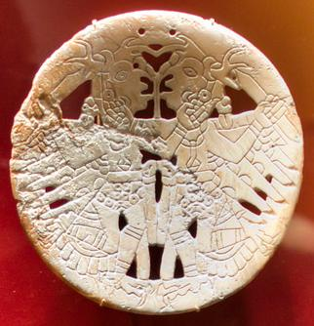

Shell gorget depicting two humans with antler headdresses each holding a sword,

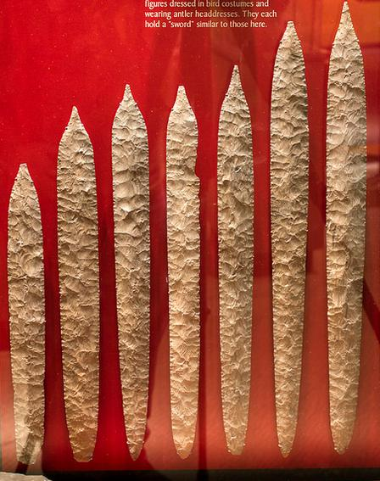

**14 3/4 (37.5 cm), 17 1/2 (44.5 cm), 18 1/4 (46.3 cm), 18 1/4 (46.3 cm), 18 1/2 (47 cm), 19 (48.2 cm), 19 (48.2 cm),**

**THE DUCK RIVER CACHE  
MISSISSIPPIAN PERIOD  
HUMPHREYS COUNTY, TENNESSEE**

**"In the late 1880's, an archaeological discovery was made in Humphreys County, Tennessee which was said at that time to be the greatest single archaeological find ever made in the United States. This discovery,----was later to become known as the "Duck River Cache----."---1981, H. C. Brehm, "The History Of The Duck River Cache," Miscellaneous Paper No. 6, Tennessee Anthropological Association, p. 1.  
    "The oval, double-pointed "flints," (swords) are, as far as known, the finest examples of flint chipping that have been discovered in North America and, possibly in the world."---1897, William J. Seever, The Antiquarian, "A Cache Of Idols And Chipped Flint Instruments In Tennessee," p. 145.  
    "The remarkable length of the objects (Duck River Cache "Swords") would at once suggest coarseness, but the chipping is as remarkable as the extreme length of the objects---."----1897, William J. Seever, The Antiquarian, "A Cache Of Idols And Chipped Flint Instruments In Tennessee," p. 145.  
    "In December, 1894, an employee of Mr. Links, while plowing in this field (on the Links farm), turned up several implements. Their form and size being unusual, time was taken to dig, and the objects (Duck River Cache)----were found"---1897, William J. Seever, The Antiquarian, "A Cache Of Idols And Chipped Flint Instruments In Tennessee," p. 141.  
    "A remarkable and unexplainable feature of the find is, that with the exception of the long, slender, double-pointed specimens, all the forms, with one exception, are in pairs of two of each form."---1897, William J. Seever, The Antiquarian, "A Cache Of Idols And Chipped Flint Instruments In Tennessee," p. 142.**

**Of all the biface forms in the Duck River Cache the most impressive are the "swords." The eight examples illustrated here represent the work of a highly skilled flintknapper. Especially when you consider the fact that they were made from nodular Dover chert. Most of the large spades, hoes, and Ramey knives, that were produced from quarry sites in southern Illinois, were made from tabular Mill Creek chert. The natural structure of the raw material makes it far more difficult to produce a Dover "sword" from thick nodules compared to a Mississippian "sword" that was produced from flat tabular chert. The longest "sword" in the Duck River cache measures 28 inches (71.1 cm) long. Some of the lengths of the other "swords" are 14 3/4 (37.5 cm), 17 1/2 (44.5 cm), 18 1/4 (46.3 cm), 18 1/4 (46.3 cm), 18 1/2 (47 cm), 19 (48.2 cm), 19 (48.2 cm), 21 3/4 (55.2 cm) and 22 (55.9 cm) inches long.**

**Most of the Duck River Cache bifaces are made from Dover chert, only a small number of them were made of Fort Payne chert. Although Dover chert outcrops in southern Illinois, western Kentucky and the Highland rim of Tennessee, the large quarry-workshops are located near Dover in Stewart County, Tennessee. In 1973, the Dover quarries were listed in the National Register of Historic Places.**

***"REFERENCES"***

**1897**, Sever, William J., The Antiquarian, "A Cache Of Idols And Chipped Flint Instruments In Tennessee," pp. 141-145.  
**1897**, Rust, Horatio N., The Antiquarian, "Survivals Of The Stone Age, And Evolution Of Certain Stone Implements," pp. 284-287. **1972**, Compton, Carl B., Ten Years Of The Tennessee Archaeologist Selected Subjects, Vol. II, " Duck River And Similar Artifacts," pp. 196-201.  
**1972**, Kneberg, Madeline, Ten Years Of The Tennessee Archaeologist Selected Subjects, Vol. II, " Engraved Shell Gorgets And Their Associations," pp. 231-269.  
**1981**, Brehm, H. C., "The History Of The Duck River Cache," Miscellaneous Paper No. 6, Tennessee Anthropological Association, pp. 1-24.  
**1992**, Gramly, Richard Michael, Prehistoric Lithic Industry At Dover, Tennessee, pp. 1 & 2.  
**2003**, McClung Museum Website, "Archaeology And The Native Peoples Of Tennessee."  
**1980's**, Personal communications with Larry Conrad.